Winter 2022 Draft Newsletter

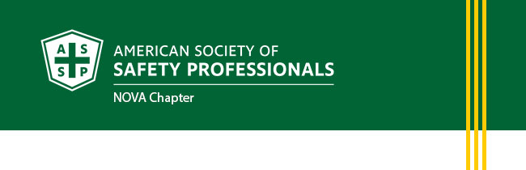
Winter Newsletter
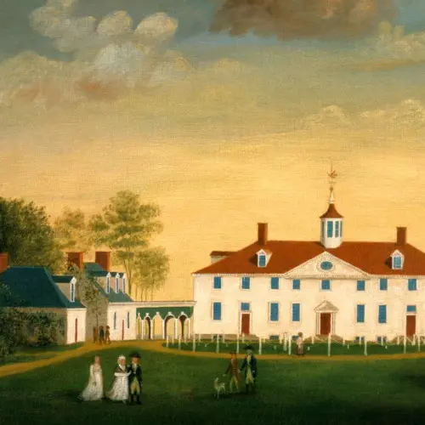
January 2022
- President’s Letter
- Upcoming Chapter Events
- Chapter News
- Volunteer With Us!
- Membership Updates
- Support for Out of Work Members
- Career Center
- Safety Focus
- ASSP Safety Podcasts
- ASSP Government Affairs Update
The American Society for Safety Professionals Northern Virginia Chapter (NOVA) in the Washington Metropolitan area was created to better serve the members of northern Virginia. Please visit https://nova.assp.org/ to provide your feedback on how NOVA can better serve you.

President’s Letter
To the New Year – CONNECT 2022!

As safety professionals we often find ourselves between a rock and a hard place enforcing policy and regulation, while working for the working class and taking orders from the C-suite. We are observers, who push agendas that make the workplace safer and healthier. Our approach is everything. We need to leave our checklist aside and start dancing with our employees (figuratively speaking). In my experience, ninety percent of safety metrics rely on changing behavior. To change behavior, we must influence behavior. To influence behavior, we must connect with our employees.

How do you do it?
Connect: Start with hello, ask about the family or the hat that they are wearing. Show Respect: Instead of enforcing, collaborate. Set expectations, not mandates. Be Kind: Remember that everyone has something going on in their lives. Kindness will have a lasting positive impact on your relationship with employees.

I hope to CONNECT with more of you this year. See you soon!

Sincerely,
Jamie Kohler, CSP, ARM
President, NOVA Chapter
American Society of Safety Professionals

Upcoming Chapter Events
1/20/22 | 12:00PM | IH - “I am not an expert but these are good things to know” | Christie DeVito
2/17/22 | 12:00PM | ISO 45001 - Occ H&S Mgmt Systems | Erica Frank
3/17/22 | 12:00PM | Heavy Equipment | United Rentals
4/21/22 | 12:00PM | General Env. Topic - SPCC, RCRA, Contaminated Soil | Bruce Donato
*Apr/May |  | Networking Event

Chapter News
The NoVA Chapter December Networking Event was a Bullseye!
December 14, 2021
THE GOLF BENEFIT 2021 WAS A HUGE SUCCESS!
October 20, 2021
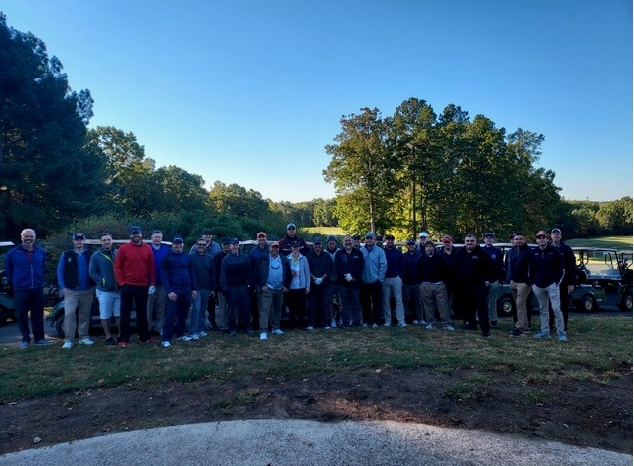
2021-2022 Chapter Meeting Schedule
September 13, 2021
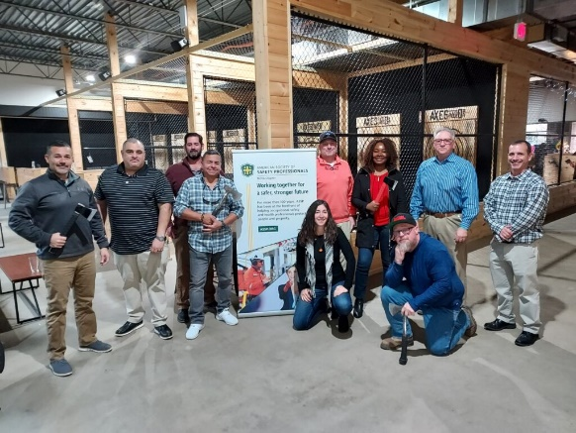
ASSP NoVA’s Ax-Throwing Acers!
Volunteer With Us!
If you are interested in volunteering, we have plenty of task force committees and special interest groups to get involved with. For more information contact president@nova.assp.org
- Program Chair – to coordinate technical seminars and assist in obtaining sponsorship
- W.I.S.E. Liaison
- MACSC Liaison
- Region VI 2024 PDC Planning subcommittee
- Emerging Young Professional subcommittee

Membership Updates

30 Years of Service – Congratulations!
Joan Andersen
Joseph Blatter
David Risi
Barbara Quinn
Vincent Miller
20 Years of Service – Congratulations!
Elfreda Edwards
Michael Kerns
Stephanie Armour
Jason Pickett

New Members – A Warm Welcome!

Cameron Freeland
Laurence Dallaire
Vinny Gallo
Anand Subramanian
Cristina Windover
Laramie Shields
Kimberly Criddle
Charles Shuck
Matt Meyers
Bruce Carter
Jennifer Furrow
Harrichand Rhambarose
John Pierro
Melissa Eng
Sierra Johnson
Ben Hunt
Robin Repass
Heidi Hill
Matthew Koss
Rich Hubner
Chris Ford
Latoya Sessoms
Bryan Krikalo
Holly Brown
Jon Pryts
Fawn Setler
Tyler Davis
Anthony Tomyn
Stacy Bonneville
Chris Hart
Chad Dutton
Deven Desai
Clint Davis
Josh Culp
Bala Raman
Hai Chua
Robin Low
Mike McCudden
Janet Oshiro
Heather Chandy
Dzuel Erwan Arip
Weiqi Lim
Joy Mathai
Lionel Singh
Carly Bouslog
Christl McDonald

Support for Out of Work Members
We know there is an increase in members who have lost their jobs during the pandemic and ASSP’s hardship program can help, encourage any member to complete the form. Individual membership contributes to the overall strength and success of the OSH profession.
For assistance members can contact ASSP Customer Service at customerservice@assp.org or +1-847-699-2929 to learn more about this program or share the Job Loss Hardship Membership Form with them. assp_hardshipform_2020.pdf

Career Center
Located at jobs.assp.org - members can post a resume, search job openings, set job search alerts, and more.
Companies looking to hire are welcome to post jobs for a fee. Internship postings are free with promo code Internships.

Safety Focus
Open to anyone in the occupational safety and health (OSH) profession who is committed to education. Whether you want to manage your job’s daily challenges, gain expertise to show your value, advance your career or maintain your safety certifications. Educational Event for Safety Professionals | SafetyFOCUS (assp.org)

ASSP Safety Podcasts
- Fall Protection Double Feature: Self-Retracting Devices and Anchorage Connectors
December 27, 2021
- Prevention through Design: Tips for Designing Out Hazards at Organizations of Any Size
November 29, 2021
- How to Earn Continuing Education Units as Safety Professional
November 15, 2021
- Navigating the Road to Success as a Woman in Safety
October 25, 2021
- What the Z459.1 Standard Means for Rope Access Systems
October 4, 2021
- From ASP to CSP: A Safety Professional’s Certification Journey
September 20, 2021
- Cultivating Relationships to Achieve Success
August 23, 2021
ASSP Government Affairs Update
The ASSP Government Affairs Update highlights important public sector actions involving occupational safety and health (OSH). Please share this newsletter with your chapter members and other ASSP colleagues. Be sure to visit our government affairs webpage to learn more.
Department of Labor Regulatory Agenda
OSHA Modernizes VPP Application Process
New Report Shows the 2019 Cost of Injury
ASSP News - Technical Comments on Issues Affecting Workplace Safety

If you do not wish to receive these emails, please click here
to unsubscribe from ASSP Northern West Virginia Chapter messages.
American Society of Safety Professionals | 520 N. Northwest Highway, Park Ridge, IL 60068

