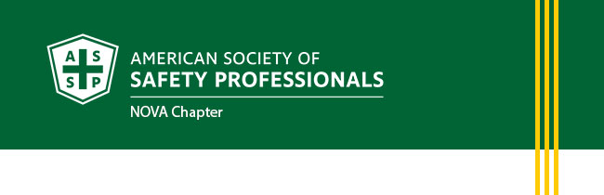
Spring Newsletter
May 2022
- President’s Letter
- Upcoming Chapter Events
- Chapter News
- Volunteer With Us!
- Membership Updates
- Career Center
- Safety Focus
- ASSP Safety Podcasts
- ASSP Government Affairs Update
The American Society for Safety Professionals Northern Virginia Chapter (NOVA) in the Washington Metropolitan area was created to better serve the members of northern Virginia. Please visit https://nova.assp.org/ to provide your feedback on how NOVA can better serve you.

President’s Letter
Effect of Employee Turnover on Workplace Safety

It is unquestionable that on-the-job training programs are essential to keeping our employees safe. They allow seasoned employees to transfer their knowledge and experience to newcomers. However, post-COVID shifts in the labor market and the associated high turnover rates have created a challenge for employee retention. With the loss of seasoned employees, effective on-the-job training programs are more difficult to produce. This in turn impacts safety.
So, what are we to do? Work on retention! A well-planned employee retention program increases organization's productivity and performance, reduces costs, and - most importantly - increases safety! Since there is not a cookie-cutter approach, we need to remember to stay cognizant of our employee's needs. Society for Human Resource Management (SHRM) identified the following effective practices for employee retention: socialization and employee engagement - help employees become embedded in the company; training and development - provide opportunities to continually update skills; compensation and rewards - link rewards to seniority and longer-term employees, supervisor relationship - train your managers in leaderships and communication.
Retain your employees, retain their knowledge base, retain your organization's human capital.
Sincerely,
Jamie Kohler, CSP, ARM
President, NOVA Chapter
American Society of Safety Professionals

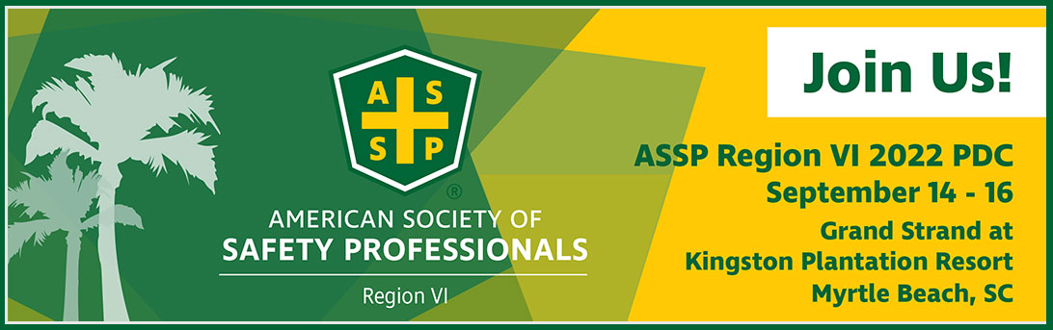
Chapter News
ASSP-NOVA’s Partnership with the AHMP Cyber Chapter Provides Access to Recordings of Technical Seminars

Well before the pandemic the NOVA chapter partnered with the Alliance of Hazardous Materials Professionals Cyber Chapter (www.ahmpcyber.org) to offer hybrid meetings to their membership. The Cyber Chapter had the expertise to broadcast the meetings to participants who could not attend in person and the capacity/technology to record the presentations and have them posted on their website. The NOVA chapter had the resources to provide the presenters for the technical content. This partnership proved very successful for both organizations.

As the pandemic hit, ASSP-NOVA and AHMP-Cyber Chapter were already set to be 100% virtual in their offering of technical seminars. Since the pandemic started this working relationship allowed for free access to all to the technical seminars and increased participation by over 100%. Most presenters agreed to allowing both their slide decks and recordings of the presentation to be posted on the Cyber Chapter website and this continues be a very success method to deliver key content to safety professionals. Visit www.nova.assp.org to see upcoming events. To find the slide decks and recordings of previous meetings click ASSP on the Library tab on the Cyber Chapter website www.ahmpcyber.org

Volunteer With Us!
If you are interested in volunteering, we have plenty of task force committees and special interest groups to get involved with. For more information contact president@nova.assp.org
- Program Chair – to coordinate technical seminars and assist in obtaining sponsorship
- W.I.S.E. Liaison
- MACSC Liaison
- Region VI 2024 PDC Planning subcommittee
- Emerging Young Professional subcommittee

Membership Updates
Ujwal Ritwik
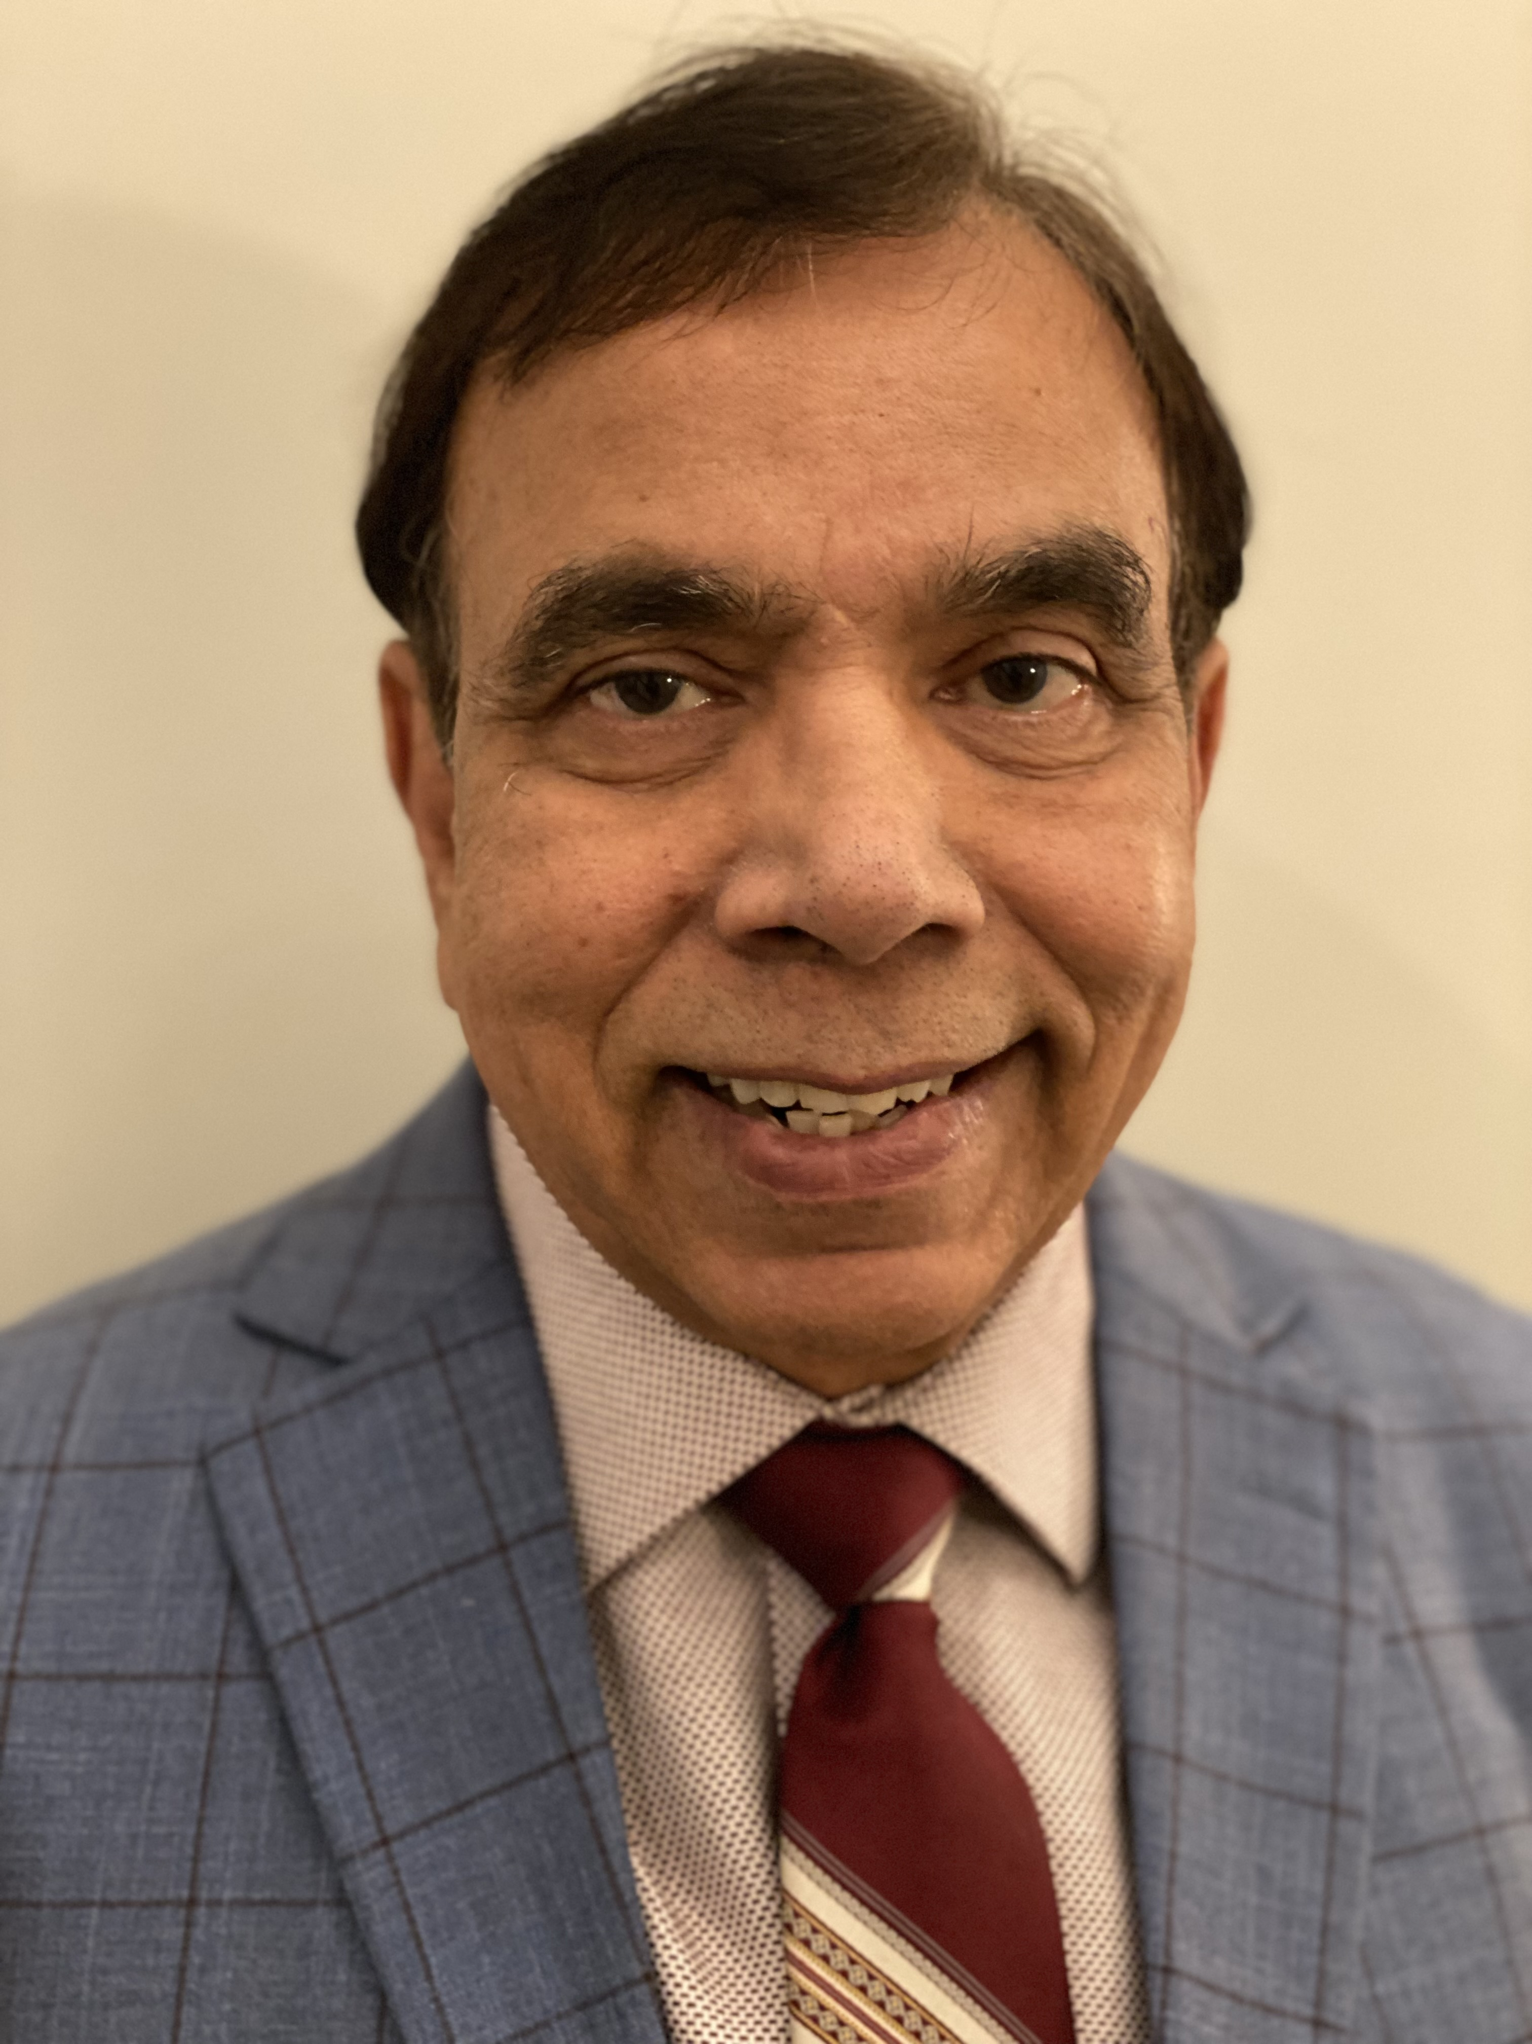
A journey in exploring the possibilities

It is a little over a year now that Ujwal has moved to Arlington, VA. Before he was in Kuwait where he was instrumental in setting up the ASSP (then ASSE) Kuwait Chapter, in the year 2000. As the founding president he also organized the first International Health Safety and Environment Conference and Expo in Kuwait. Later he led setting up the Gulf Cooperation Council Health Safety and Environment Excellence Award. The ASSP Kuwait Chapter has now grown into the largest international chapter, and the two events are in their 13th and 15th editions respectively.
Ujwal has a BS in Chemical Engineering and further Diplomas in Environmental Engineering, and Business Management. He has worked in a variety of high hazard industry including nuclear, petroleum, petrochemicals and other critical infrastructure. Currently he offers independent auditing, training and consulting as the Principal at Center for Professional Excellence in Risk and Sustainability LLC. He serves as a member on the Board of Global Credentialing for EHS (BGC), a member of the Technical Advisory Group of ASSP/ANSI for TAC 283 on ISO 45001:2018 and now has joined the Board of NOVA chapter.
(We encourage all members to send their brief resume and photograph to introduce them on this column.)
Upcoming Events
- May Meeting – Annual Virginia Occupational Safety and Health (VOSH) Update
  - May 19, 2022 12:00 pm – 1:30 pm

- June Meeting – Legal Updates: OSHA and MSHA
  - June 16, 2022 12:00 pm – 1:00 pm
Career Center
Located at jobs.assp.org - members can post a resume, search job openings, set job search alerts, and more.
Companies looking to hire are welcome to post jobs for a fee. Internship postings are free with promo code Internships.

Safety Focus
Advance your career - Attend a safety course in-person or online
Open to anyone in the occupational safety and health (OSH) profession who is committed to education. Whether you want to manage your job’s daily challenges, gain expertise to show your value, advance your career or maintain your safety certifications. Educational Event for Safety Professionals | SafetyFOCUS (assp.org)

ASSP Safety Podcasts
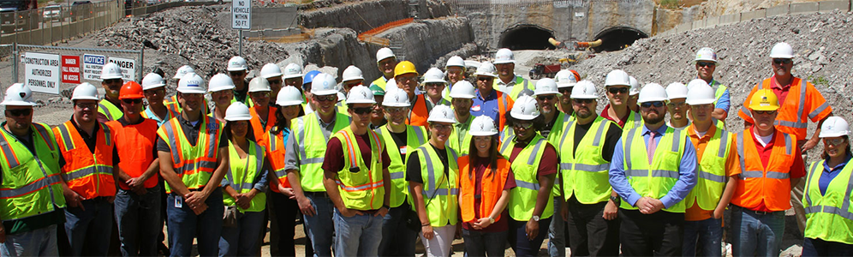
- How Safety Managers Can Help Address Mental and Behavioral Health
- What the Updated Z117 Standard Means for Confined Space Safety
- Using Worker Feedback to Improve Your Safety and Health Management System
- How the Z16 Standard Can Help You Improve Metrics and Performance Measures
- Encore Presentation: Proper Ergonomics for Your Home Workspace
- Safety Managers: Here’s How to Overcome Common Objections
ASSP News
- Using the Z16.1 Standard to Improve Safety Metrics and Performance Measures
- 10 Proven Methods For Delivering Feedback as a Safety Manager
- New Standard Helps Organizations Prevent Workplace Injuries
- How Worker Engagement Can Help Improve Your Safety Management System
- Giving a Safety Presentation? These Tips From Stage Performers Will Protect Your Voice
- 3 Ways For Women in Safety Leadership to Make Big Career Moves
- OSHA Proposes Rule to Improve Tracking of Workplace Injuries and Illnesses
- Asian American Achievements in Safety
ASSP Government Affairs Update
The ASSP Government Affairs Update highlights important public sector actions involving occupational safety and health (OSH). Please share this newsletter with your chapter members and other ASSP colleagues. Be sure to visit our government affairs webpage to learn more.
American Society of Safety Professionals | 520 N. Northwest Highway, Park Ridge, IL 60068

